**ITP3006**

**Web Assignment**

**170313580 Law Siu Yin**

**170114290 Kam Ho Kai**

**The index page:**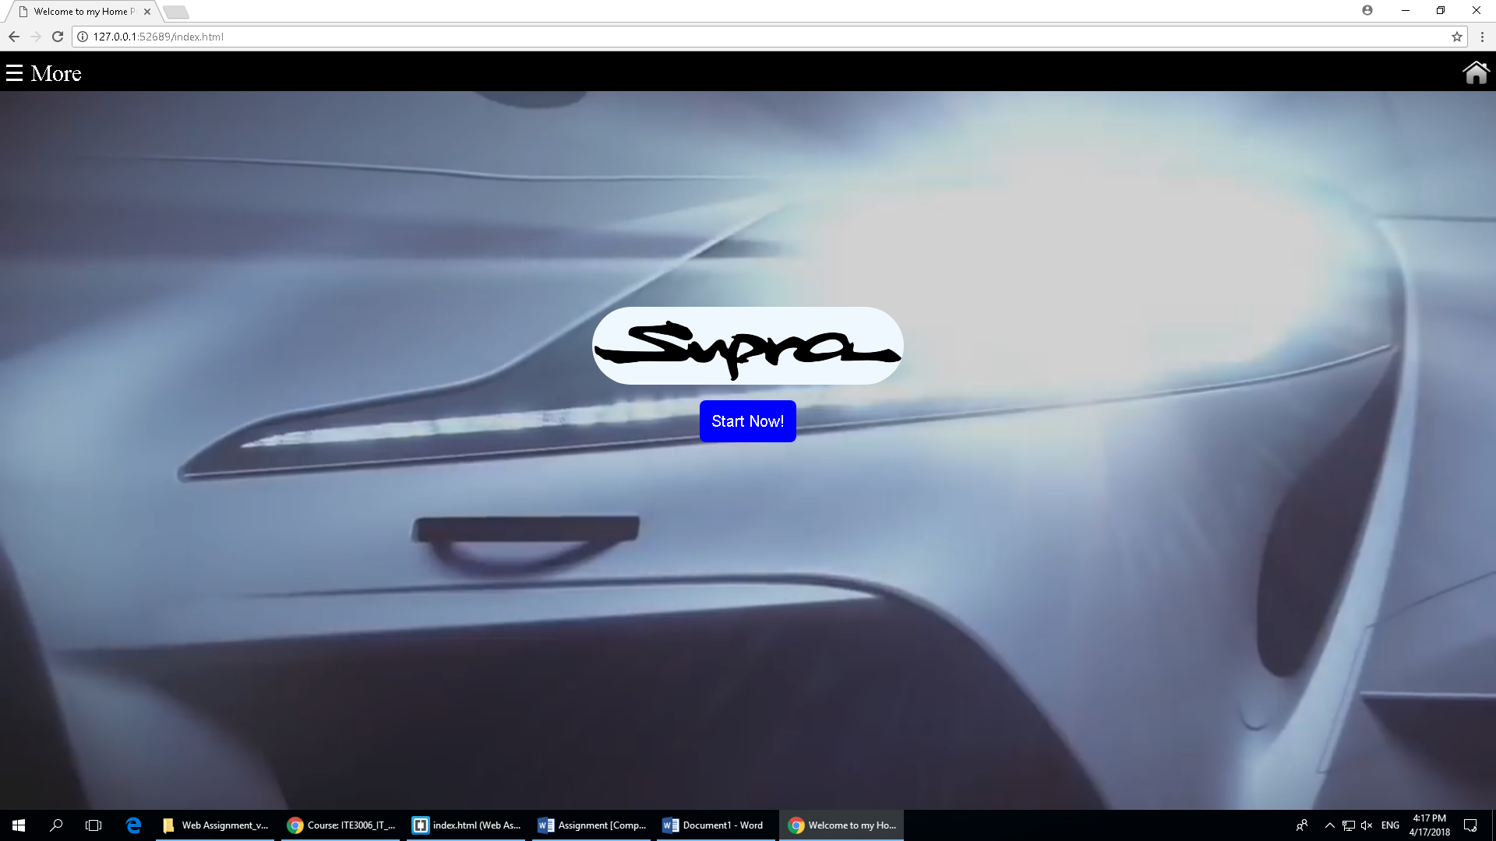

A button whish will go to the history page

A popup menu to go to others page

A video which is playing in background

The logo of supra which is using border-radius is css

A button to go to home page

The header whish will lock on the top of the page

**The History page:**

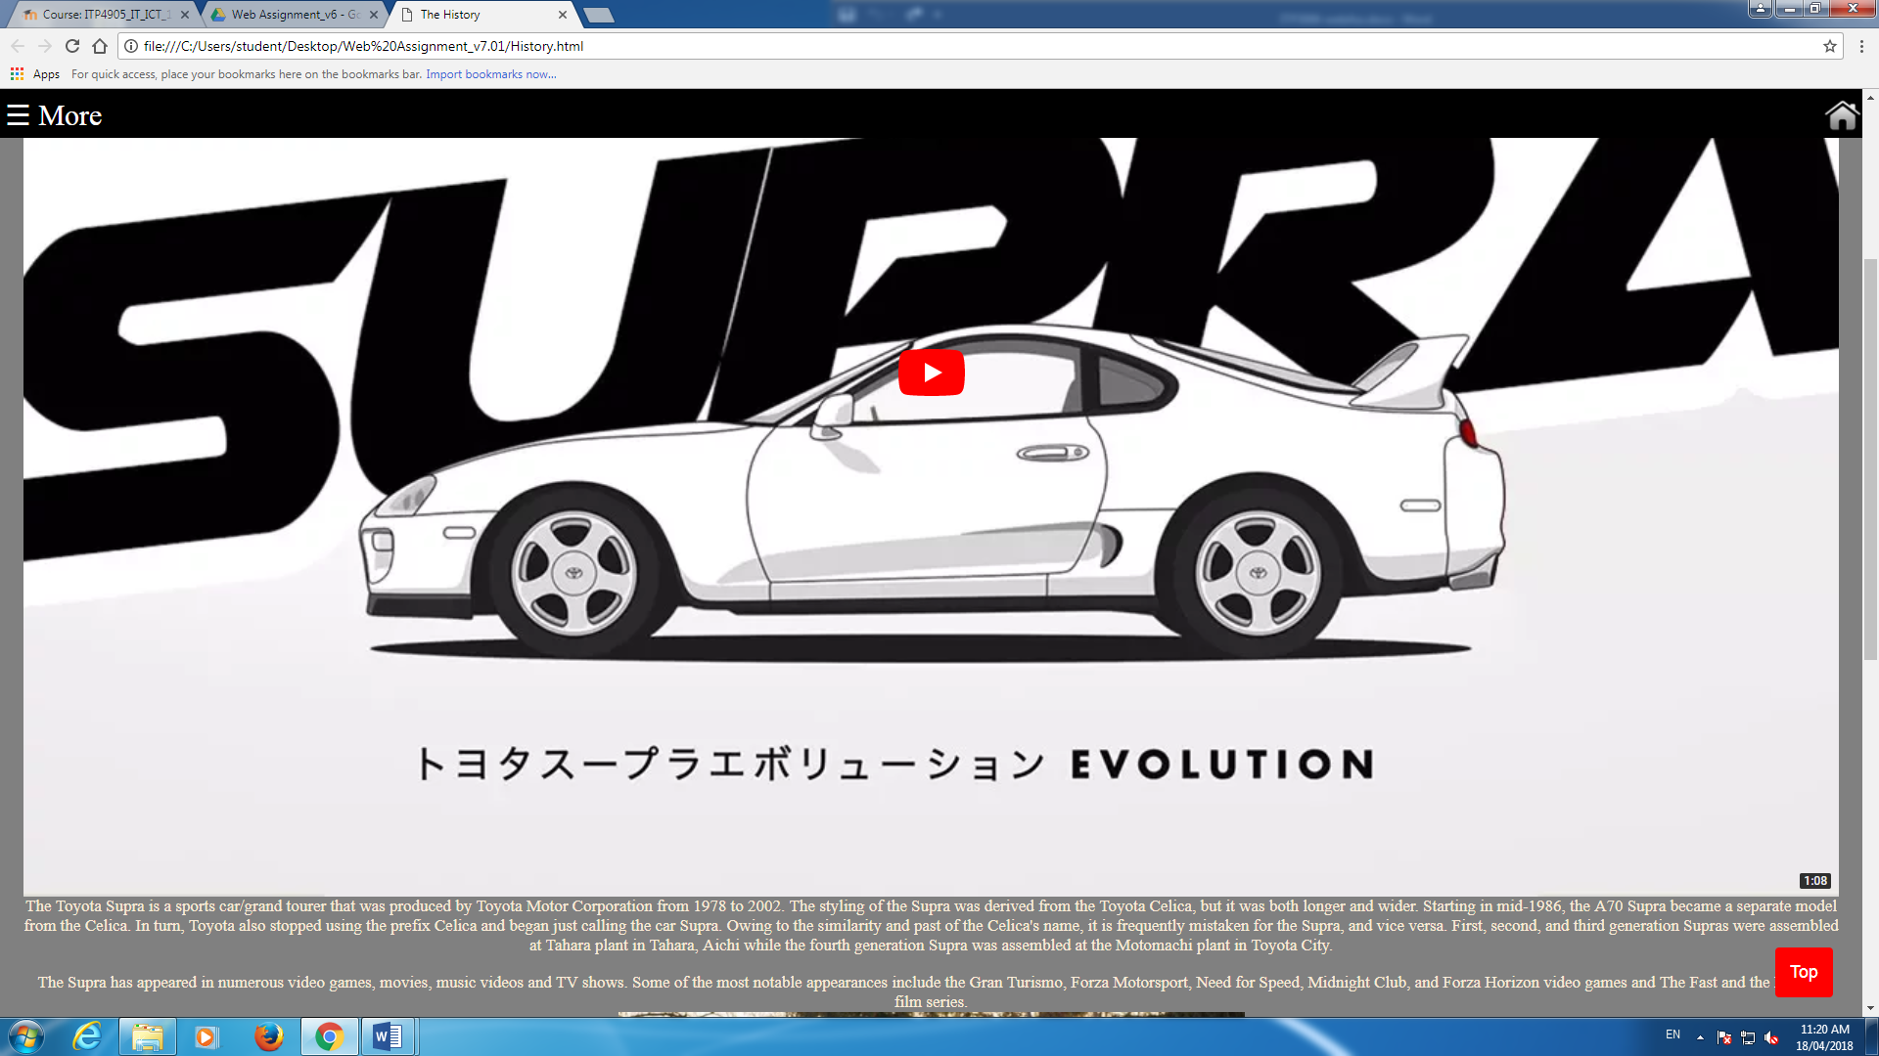

Briefly explain about this car.

A video which explain the history of this car and its series.

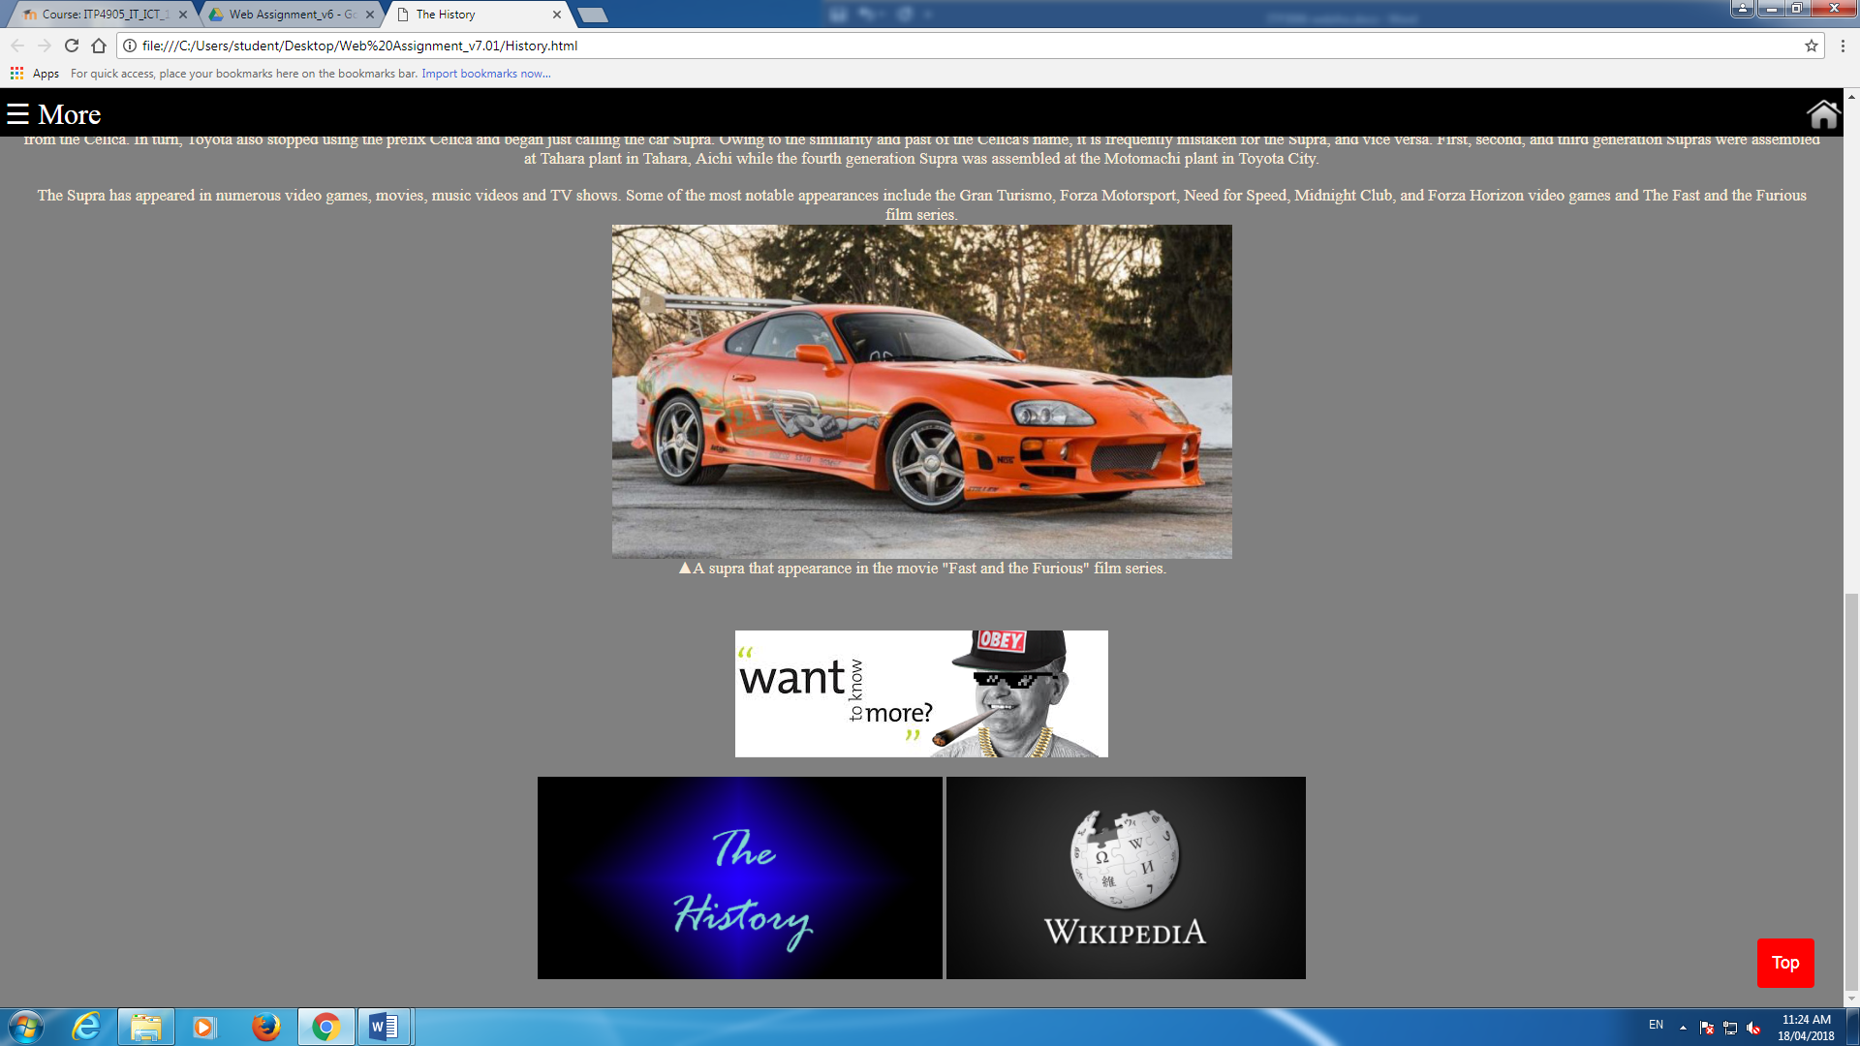

A banner and some reference link for the viewer who wants to know more.

**The About Us page:**

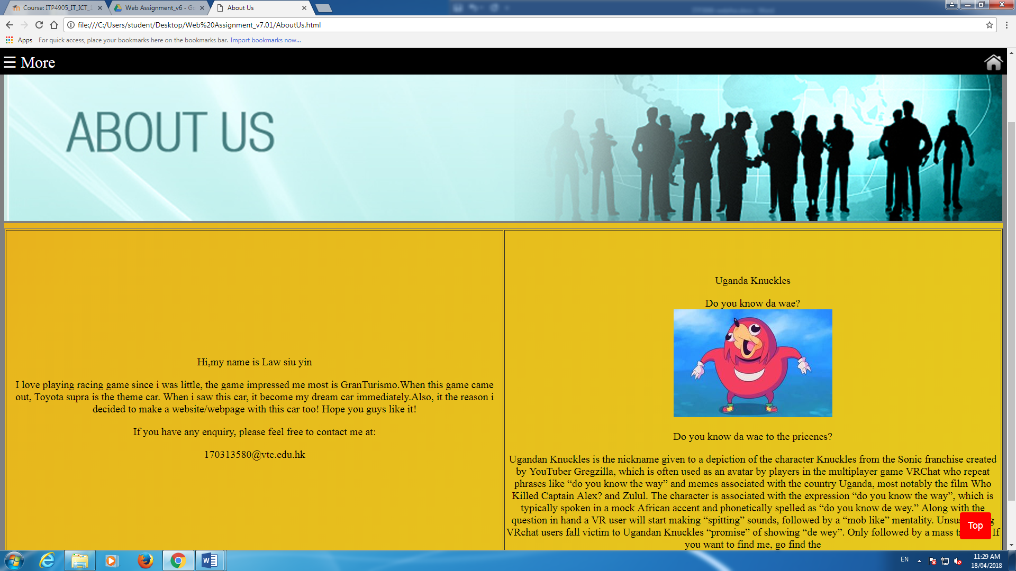

Some text to describe the author.

Describe how the meme from

A hidden picture will show when you mouse on it.

The background will change color automatically with css.

A banner.

**The Favorite page:**

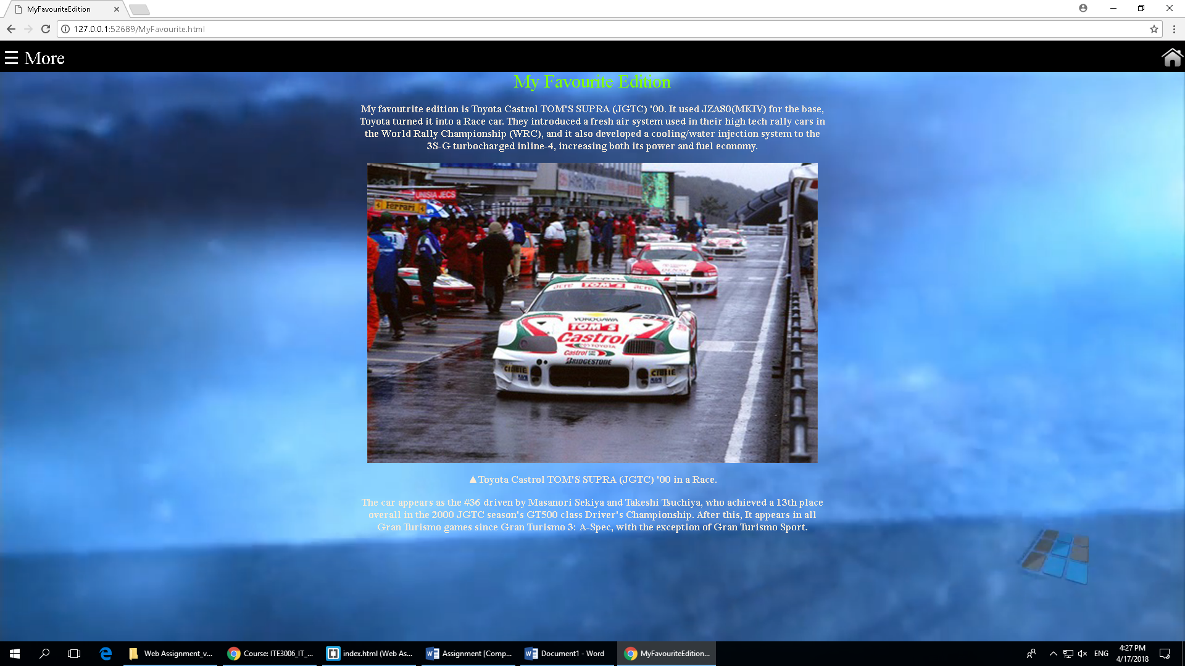

We insert a video first, muted in background, then set the min width and height to 100% to make it fullscreen.

The description about the favorite edition

A video which is playing about supra

**The contact page:**

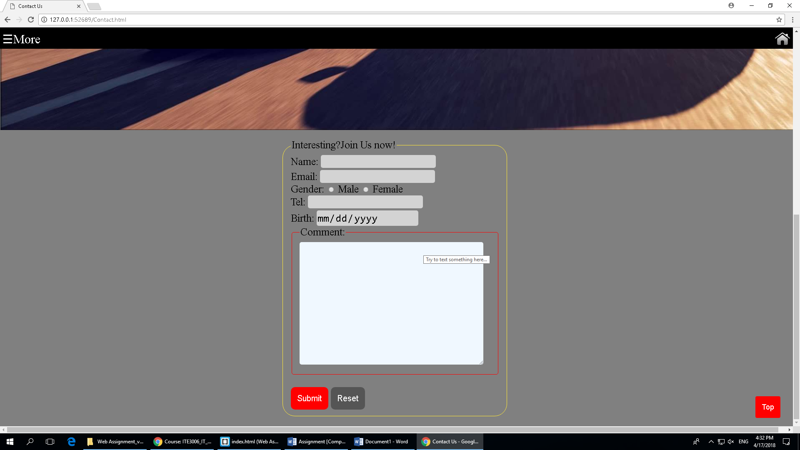

The input must be 0-9 and maximum is 13 numbers.

The gender

A submit button which will save the input of the form and launch a popup checkbox to confirm the form input isn’t correct or not

The input type is email, the input box must having @

The name which need to start by capital letter

A reset button which will reset all the input in the form above

A to top button whish will go to the top of the page by clicking in every page

A banner which is using keyframes in changing opacity in 1.1s